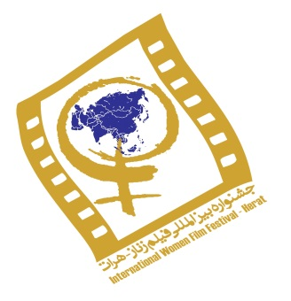

4th edition
International Women’s Film Festival, Afghanistan
11– 15 October 2016

Please fill out and complete the form below as clearly and completely as possible in capital letters
After completing the form, please print, sign and send it along with the English subtitled online version or preview DVD before 15 July 2016(see details below):

Entry Form

3rd Afghanistan International Women Film Festival | 11 – 15 October 2016
Section 1: General & Technical Information
Original Title:
English Title:
Date of Production:
Production Country:
Original Language:
Type of Film:

Feature:
Documentary:
Short Film:

Animation :
Duration:
Color: □ Color □ Black & white □ Color & B.W
Aspect Ratio: □ 1.33 □ 1.66 □ 1.85 □ 4.3 □ 16.9 □ Other
Shooting Format: □ 35 mm □ DVCAM □ Video □ HD □ Other ….
Participation in Other Festivals:
Awards (if any):

Synopsis (not more than 10 lines):

11-15 October 2016
Director’s Full Name:
Nationality:
Contact:

Address:
Tel:

E-mail:

Director’s Biography and Filmography (not more than 10 lines):

Producer:
Scriptwriter’s Name:
Director of Photography:

Editor:
Sound mixer:
Composer:
Main Actors/Actresses:

CONTACTS AND LINK
URL LINK TO FILM ON-LINE :
Full Name of Contact person:
Tel:

Skype or Viber:
E-mail:

11-15 October 2016

By signing below, you agree to the terms and conditions of the 4th edition of the International Women’s Film Festival-Herat, Afghanistan hereunder and confirm that you have read and accepted the 4th Edition Film Festival’s Entry Guidelines.

The following will apply for all film submissions:

- 4th edition of International Women’s Film Festival-Herat, Afghanistan retains the right to archive the submitted DVD screener copy of my film and will not return any DVD screening copy.
- DVDs for viewing purposes must be sent (if via Courier services) with the following customs Declaration: “No commercial value, for cultural purposes only”.

PLEASE SEND (by email and/or courier) TO FOLLOWING ADDRESS (NOTE that the Festival will not be able to consider incomplete Submissions):
- Fully Completed Entry Form
- English subtitled DVD screener or link to on-line film which can be downloaded
- CD (or email) including Synopsis in English
- stills of the film
- Photo of the director

NOTE: For films from Afghanistan and Iran please also complete the form in Persian/Dari

CONTACT
Email: womenfilmfestival.herat@gmail.com
Postal Address: Roya Film House, 1st Alley of Dehmazang/Tappeh Salam,
Opposite Mohammadieh Mosque, Kabul, Afghanistan.
Tel: Afghanistan: +93798106275/ +93707139784/ +93700427244
Tel: International contact: +33662153297/+331646531624
Website: http://afghanistanintwomenfilmfestival.com/
Facebook: https://www.facebook.com/afghanistanwomenfilmfestival

Signature: ……………………………………………….. Date: ....... /……. /……

